Lab 4.2 — Closing the Loop: Write-Back Actions with Streamlit

Table of Contents
Table of Contents 2
Introduction 3
Learning Objectives 3
Prerequisites 3
Part 1 — Preparing the Database for Action 5
Step 1 — Evolve the Schema and Create the Action Procedure 5
Part 2 — Building the Interactive "Action Center" 7
Step 1 — Create the Streamlit Application 7
Part 3 — Testing the End-to-End Write-Back Loop 10
Step 1 — Test Dynamic AI Drafting 10
Step 2 — Execute the Human-in-the-Loop Write-Back 12
Step 3 — Verify the Audit Trail 12
Knowledge Check 14
Troubleshooting 14
Symptom: The UI flashes success, but the ticket doesn't disappear from the dropdown queue. 14
Symptom: SQL execution error when clicking the Resolve button. 14
Conclusion 15

Introduction
The primary limitation of traditional BI is that it is unidirectional: it displays insights, but it cannot fix the underlying problems. If an AI model tells a user that a ticket requires an immediate response, the user typically has to copy that insight, switch to a completely different CRM or ticketing application, paste the data, and resolve it there.
By using Streamlit in Snowflake (SiS), we can create a bidirectional bridge between the AI dashboard and the data warehouse. In this lab, you will evolve your Command Center from a passive "read-only" dashboard into an active, multi-tab application. You will generate AI-drafted responses, dynamically adjust the AI's tone, allow the user to edit those drafts, and use a UI button to trigger a Snowflake Stored Procedure that writes the resolution directly back into the database. Finally, you will build an Audit Trail to monitor these write-backs in real time.

Learning Objectives
Upon completing this lab, you will be able to:
- Mutate existing operational tables to support state tracking (e.g., Open/Resolved statuses).
- Author a Snowflake Stored Procedure to act as a secure backend write-back mechanism.
- Architect multi-view Streamlit applications using st.tabs.
- Programmatically adjust LLM prompts based on UI widget state (Tone Adjustments).
- Manage complex UI interactions using Streamlit's st.session_state.
- Programmatically invalidate and clear Streamlit data caches (st.cache_data.clear()) after executing a database transaction.

Prerequisites
Before starting, ensure you have:
- Completed Lab 4.1 (the customer_support_tickets table and its mock data must exist).
- Access to the Snowsight Web UI with the SYSADMIN role.
- The SNOWFLAKE.CORTEX_USER role granted to your active session.

Part 1 — Preparing the Database for Action
To close a ticket, our database needs to know what a "closed" ticket looks like. We will add a status tracking column to our existing table and create the Stored Procedure that our Streamlit app will eventually call to securely mutate the data.

Step 1 — Evolve the Schema and Create the Action Procedure
We must guarantee that the status column exists before the Stored Procedure compiles, otherwise Snowflake will throw an invalid identifier 'STATUS' error.
Execute the following combined SQL block in a standard Snowflake Worksheet to update the table and create the procedure in the exact required sequence:
USE DATABASE ENTERPRISE_AI_SANDBOX;
USE SCHEMA ANALYTICS;

-- 1. Add the missing column FIRST
ALTER TABLE customer_support_tickets ADD COLUMN IF NOT EXISTS status VARCHAR(20) DEFAULT 'OPEN';
UPDATE customer_support_tickets SET status = 'OPEN';

-- 2. THEN create the Stored Procedure
-- We use a Stored Procedure so the frontend UI doesn't run arbitrary UPDATE commands directly.
CREATE OR REPLACE PROCEDURE resolve_support_ticket(p_ticket_id VARCHAR, p_resolution_note VARCHAR)
RETURNS STRING
LANGUAGE SQL
AS
$$
BEGIN
-- Update the status to RESOLVED and append the resolution note to the transcript history
UPDATE customer_support_tickets
SET
status = 'RESOLVED',
issue_transcript = issue_transcript || ' || [SYSTEM NOTE - RESOLVED: ' || :p_resolution_note || ']'
WHERE ticket_id = :p_ticket_id;

RETURN 'SUCCESS';
END;
$$;

Expected Output:
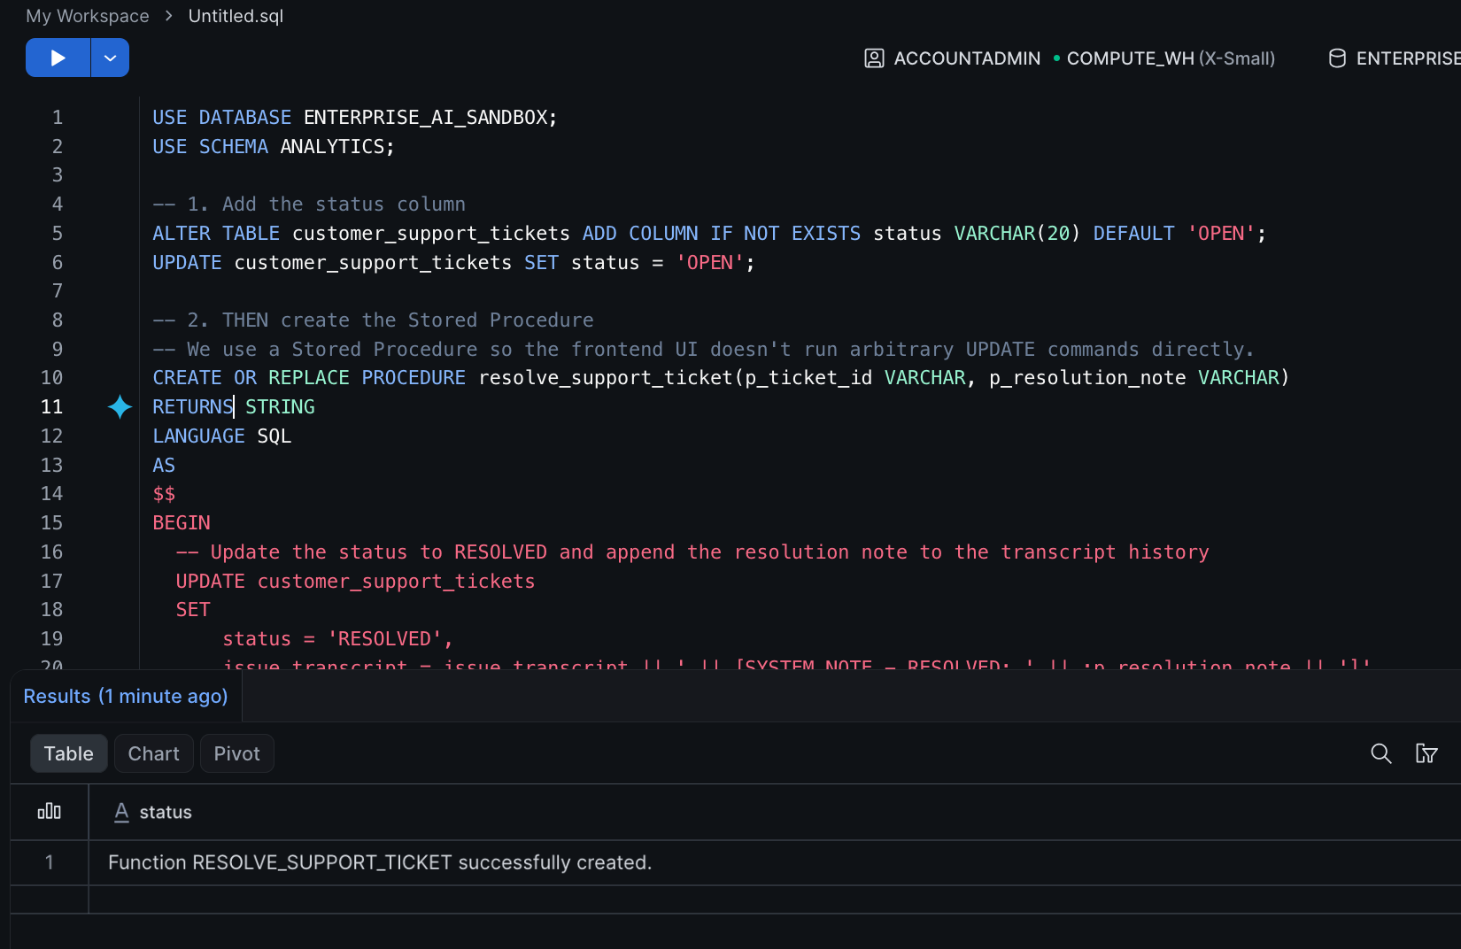
Function RESOLVE_SUPPORT_TICKET successfully created.

Part 2 — Building the Interactive "Action Center"
We will now build a new Streamlit application utilizing a tabbed interface. This separates the operational workspace from the historical audit view.

Step 1 — Create the Streamlit Application
- In Snowsight, navigate to Workspaces and click + Add new -> Streamlit App.
- Name the application AI Action Center.
- Delete the boilerplate code and replace it with the following Python script.
import streamlit as st
from snowflake.snowpark.context import get_active_session

st.set_page_config(layout="wide", page_title="AI Action Center")
st.title("⚡ AI Action Center: Close the Loop")
st.markdown("Select open tickets, utilize AI to draft tone-adjusted responses, and securely resolve them in the database.")

session = get_active_session()
session.use_database("ENTERPRISE_AI_SANDBOX")
session.use_schema("ANALYTICS")

# 1. Fetch tickets based on status (Cached for performance)
@st.cache_data(show_spinner=False)
def fetch_tickets_by_status(status_filter):
try:
return session.sql(f"SELECT * FROM customer_support_tickets WHERE status = '{status_filter}' ORDER BY created_at ASC").to_pandas()
except Exception as e:
# Gracefully handle the error if the user skipped Part 1
st.error("🚨 **Database Schema Error:** The `status` column is missing from the table. Please ensure you ran the SQL commands in **Part 1** of this lab to update the table schema before running this app.")
st.stop()

# 2. Build the Tabbed UI
tab_workspace, tab_audit = st.tabs(["🎫 Agent Workspace", "📜 Resolution Audit Log"])

# ==========================================
# TAB 1: AGENT WORKSPACE (WRITE-BACK)
# ==========================================
with tab_workspace:
df_open_tickets = fetch_tickets_by_status('OPEN')

if df_open_tickets.empty:
st.success("🎉 Inbox Zero! All customer support tickets have been resolved.")
else:
col1, col2 = st.columns([1, 2])

# --- Left Column: Ticket Selection ---
with col1:
st.subheader("Open Ticket Queue")
ticket_options = df_open_tickets['TICKET_ID'] + " (" + df_open_tickets['REGION'] + ")"
selected_dropdown = st.selectbox("Select a ticket to triage:", ticket_options)

selected_id = selected_dropdown.split(" ")[0]
ticket_details = df_open_tickets[df_open_tickets['TICKET_ID'] == selected_id].iloc[0]

st.info(f"**Customer Tier:** {ticket_details['CUSTOMER_TIER']}\n\n**Transcript:**\n{ticket_details['ISSUE_TRANSCRIPT']}")

# --- Right Column: AI Drafting & Tone Adjustment ---
with col2:
st.subheader("AI Agent Resolution Workspace")

# Allow the agent to dynamically alter the AI's prompt constraints
selected_tone = st.radio("Desired Response Tone:", ["Professional", "Empathetic", "Direct"], horizontal=True)

if st.button("🤖 Generate AI Response Draft", type="secondary"):
with st.spinner(f"Drafting a {selected_tone.lower()} response..."):
prompt = f"Draft a 2-sentence resolution message to the customer regarding this issue. The tone MUST be {selected_tone}. Issue: {ticket_details['ISSUE_TRANSCRIPT']}"

safe_prompt = prompt.replace("'", "''")
query = f"SELECT SNOWFLAKE.CORTEX.COMPLETE('llama3.1-8b', '{safe_prompt}') as AI_RESPONSE"
result = session.sql(query).collect()

# Save the draft to session state to survive UI reruns
st.session_state['ai_draft'] = result[0]['AI_RESPONSE']

# Human-in-the-Loop Review & Execution
if 'ai_draft' in st.session_state:
st.caption("Review and edit the AI-generated draft before saving:")
final_resolution = st.text_area("Final Resolution Note:", st.session_state['ai_draft'], height=150, label_visibility="collapsed")

if st.button("✅ Approve & Resolve Ticket", type="primary"):
with st.spinner("Writing back to Snowflake database..."):
# Execute the backend stored procedure
safe_note = final_resolution.replace("'", "''")
session.sql(f"CALL resolve_support_ticket('{selected_id}', '{safe_note}')").collect()

st.success(f"Ticket {selected_id} successfully resolved!")

# Enterprise UI Refresh Logic
del st.session_state['ai_draft'] # Clear the text box state
fetch_tickets_by_status.clear() # INVALIDATE THE CACHE to force fresh DB read
st.rerun() # Refresh the page instantly

# ==========================================
# TAB 2: AUDIT LOG (VERIFICATION)
# ==========================================
with tab_audit:
st.subheader("Recently Resolved Tickets")
df_resolved_tickets = fetch_tickets_by_status('RESOLVED')

if df_resolved_tickets.empty:
st.info("No tickets have been resolved yet. Use the Agent Workspace to clear the queue!")
else:
# Display the resolved tickets to prove the write-back worked
st.dataframe(
df_resolved_tickets[['TICKET_ID', 'CUSTOMER_TIER', 'REGION', 'ISSUE_TRANSCRIPT']],
use_container_width=True
)
st.caption(f"Showing {len(df_resolved_tickets)} successfully processed record(s).")

Click Run (or Cmd/Ctrl + Enter) in the top left to launch the multi-tab application.

Part 3 — Testing the End-to-End Write-Back Loop
Now we will test the complete lifecycle of a ticket, leveraging different AI tones and verifying the audit trail.

Step 1 — Test Dynamic AI Drafting
- Ensure you are on the 🎫 Agent Workspace tab.
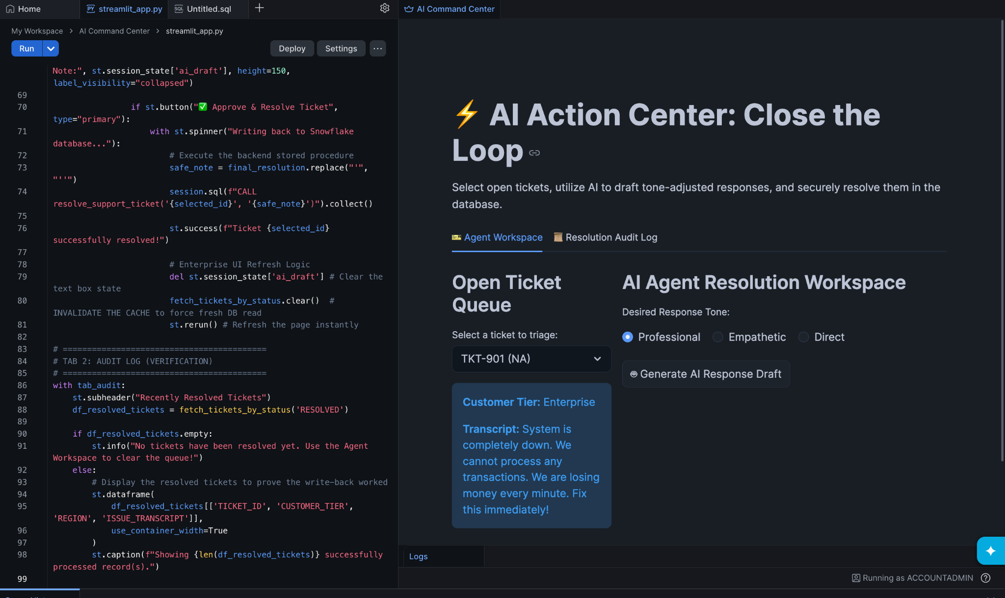
- Select a ticket from the dropdown in the left column (e.g., TKT-901).
- Set the Desired Response Tone radio button to Empathetic.
- Click 🤖 Generate AI Response Draft. Notice how Cortex formulates a highly apologetic response prioritizing customer feelings.
- Change the radio button to Direct and click the generate button again. Notice how the AI drastically shifts its vocabulary to be blunt and action-oriented.
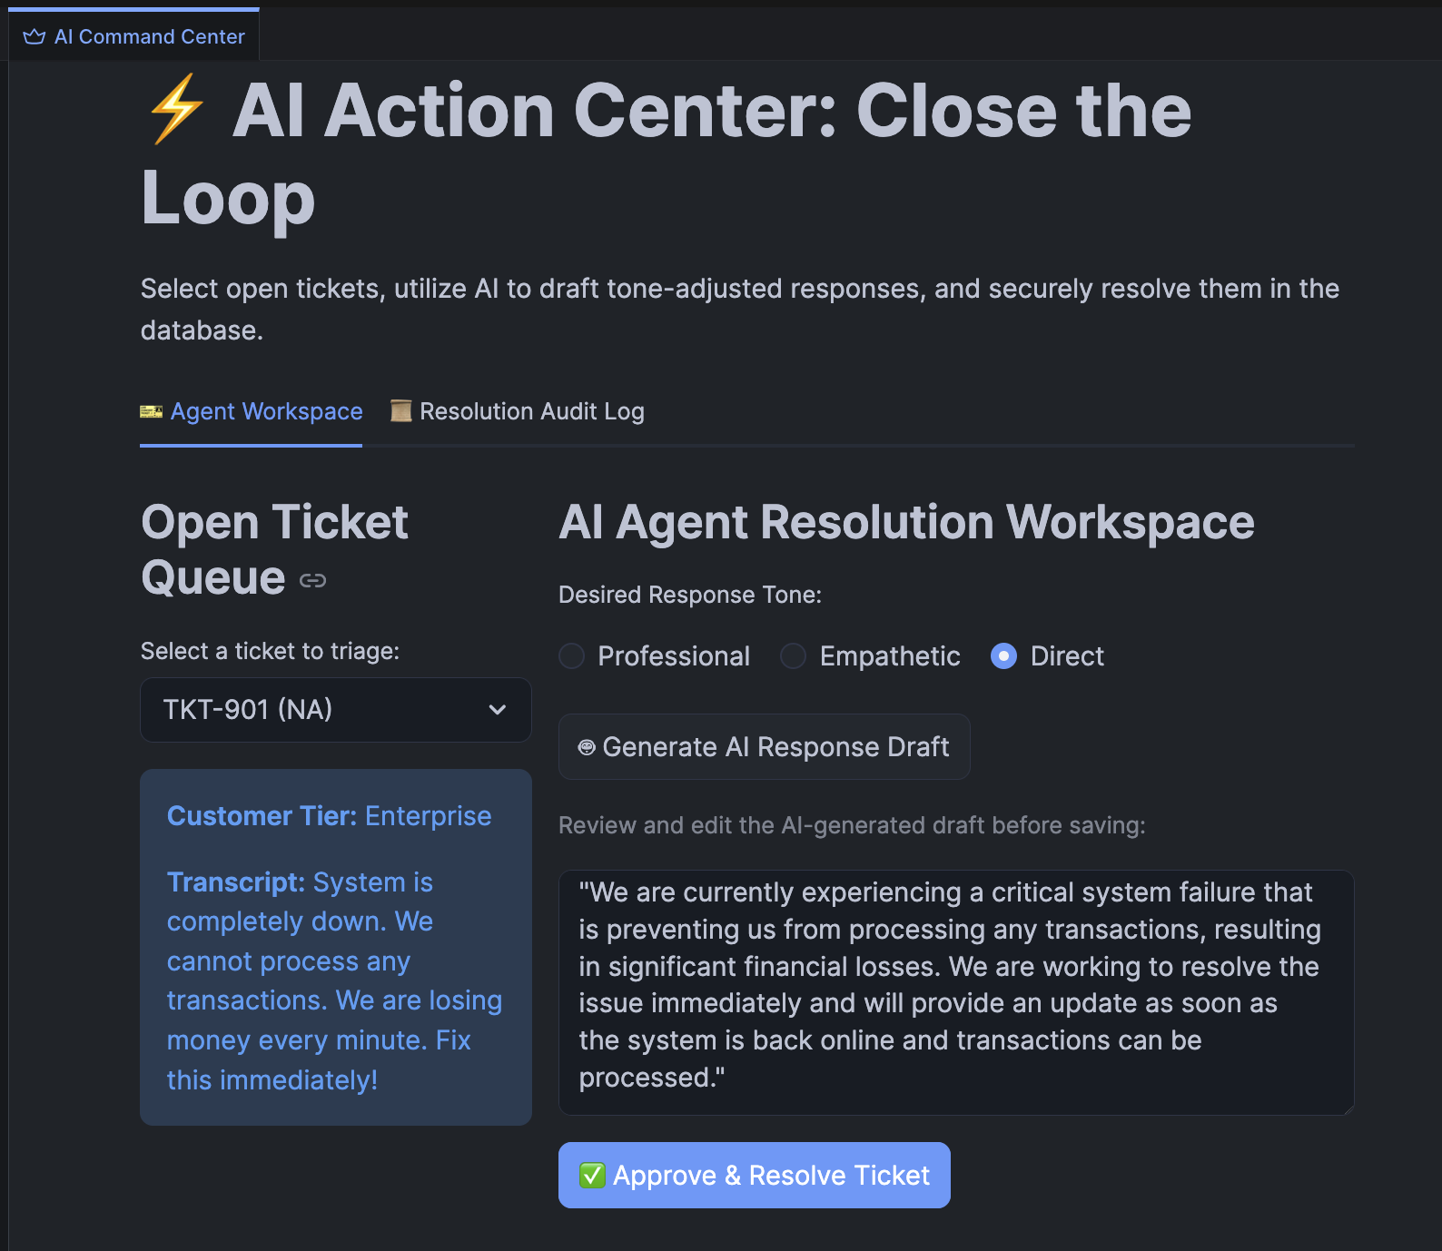

Step 2 — Execute the Human-in-the-Loop Write-Back
- Edit the final text slightly in the text area (e.g., add your name to the signature).
- Click the green ✅ Approve & Resolve Ticket button.
- Observe the App State: The app instantly reruns. TKT-901 completely vanishes from the open dropdown queue, and the next ticket automatically loads!

Step 3 — Verify the Audit Trail
- At the top of the application, click on the 📜 Resolution Audit Log tab.
- You will now see TKT-901 populated in this data table!
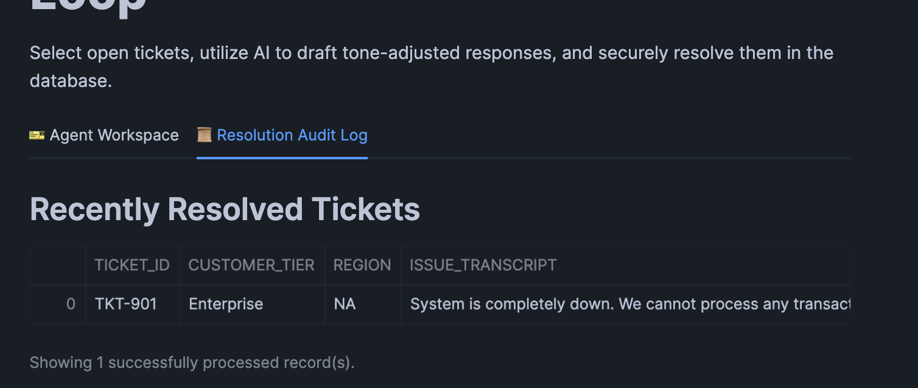

Knowledge Check
- Why must we call fetch_tickets_by_status.clear() immediately after calling the Stored Procedure?
  - Answer: Because fetch_tickets_by_status() uses the @st.cache_data decorator (for performance), Streamlit will keep serving the old, cached data showing the ticket as 'OPEN'. By explicitly calling .clear(), we invalidate the cache, forcing the app to query Snowflake again on the next st.rerun(), ensuring the UI perfectly reflects the live database state.
- Why do we use st.session_state['ai_draft'] instead of simply assigning the AI response to a standard Python variable like ai_draft = result[0]['AI_RESPONSE']?
  - Answer: Streamlit apps rerun completely from top to bottom every time a user interacts with a widget (like clicking a radio button or typing in a text area). If we used a standard variable, the moment the user tried to edit the AI's text, the script would rerun, the variable would reset to empty, and the text box would vanish! st.session_state preserves data across these interactive reruns.

Troubleshooting

Symptom: The UI flashes success, but the ticket doesn't disappear from the dropdown queue.
Solution: This means the cache wasn't cleared before the UI refreshed. Ensure that fetch_tickets_by_status.clear() is called exactly as written before st.rerun().

Symptom: SQL execution error when clicking the Resolve button.
Solution: The user likely typed a single quote (') into the text area, breaking the SQL CALL statement formatting. Ensure you are applying .replace("'", "''") to the final_resolution string before interpolating it into the session.sql() string.

Conclusion
In this lab, you advanced far beyond traditional, passive BI dashboards. You engineered a fully interactive, bidirectional application that seamlessly integrates Snowflake Cortex for dynamic text generation, Streamlit Tabs for organizational layout, Python for complex state management, and SQL Stored Procedures for secure database mutations. You have successfully implemented the ultimate paradigm in modern data engineering: closing the loop on Generative AI.

